- Docker containers share the same Kernel of the host machine.
  - If the system has linux kernel, then you can’t run windows container in that system.
  - The OS of the container should be compatible with the kernel of the host machine.
  - 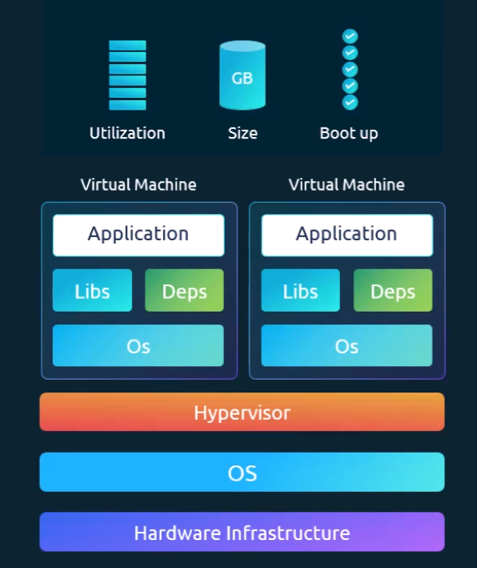 (virtual machine)
  - 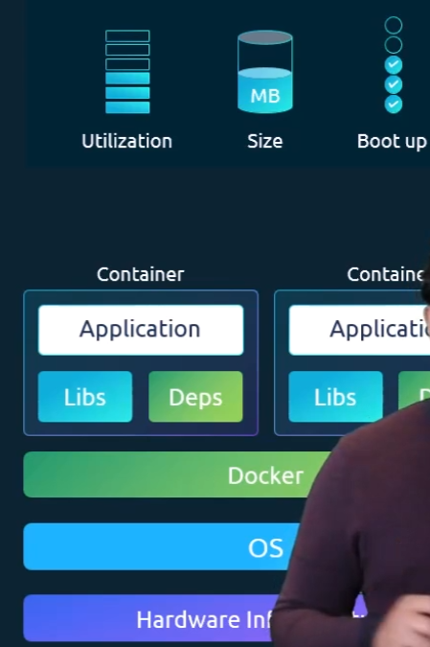 (Docker)

- When you install Kubernetes in a system, then the following things are installed:
  - API Server
    - It acts as the frontend of kubernetes cluster.
  - etcd
    - Distributed key-value store that keeps the cluster information(i.e. all details about worker nodes and master nodes) of kubernetes to manage the cluster.
  - Kubelet
    - Make sure containers are running inside the nodes.
  - Container Runtime
    - Underlying software used to run software.
    - Docker has “containerd”.
  - Controller
    - Brain behind the orchestration.
    - It takes decision to bring up new containers if nodes or pods goes down.
  - Scheduler
    - Implementing locks within the cluster to ensure there are no conflicts.
    - Assign the nodes to the pods.
- How does nodes are divided into master and slave?
  - Each worker node contains Container Runtime like containerd.
Other container runtime are also available like rkt, CRI-O.
  - Master node contains kube-apiserver and Worker node contains kubelet ,
this kube-apiserver makes the node master.
  - Kubelet agent of the worker node connects with the master node to do the things.
- Basic commands:
  - kubectl run hello-minikube
kubectl run command is used to deploy an application to the cluster.
  - kubectl cluster-info
it gives the information about the cluster.
  - kubectl get nodes
it list all the nodes of the cluster.
- Docker vs containerd
  - Kubernetes introduced an interface called CRI (container runtime interface)
  - CRI allowed every vendor to work as a container runtime for kubernetes as long as they follow the OCI (open container initiative) standard.
  - This CRI has 2 specs:
    - imagespec
it is the specification about how an image should be built.
    - runtimescape
it is the specification about how any container runtime should be developed.
  - Docker was there way before CRI was introduced. So, Kubernetes introduced dockershim to use Docker which was a temporary solution.
  - Now, Docker Runtime (containerd) contains inbuilt CRI.
  - 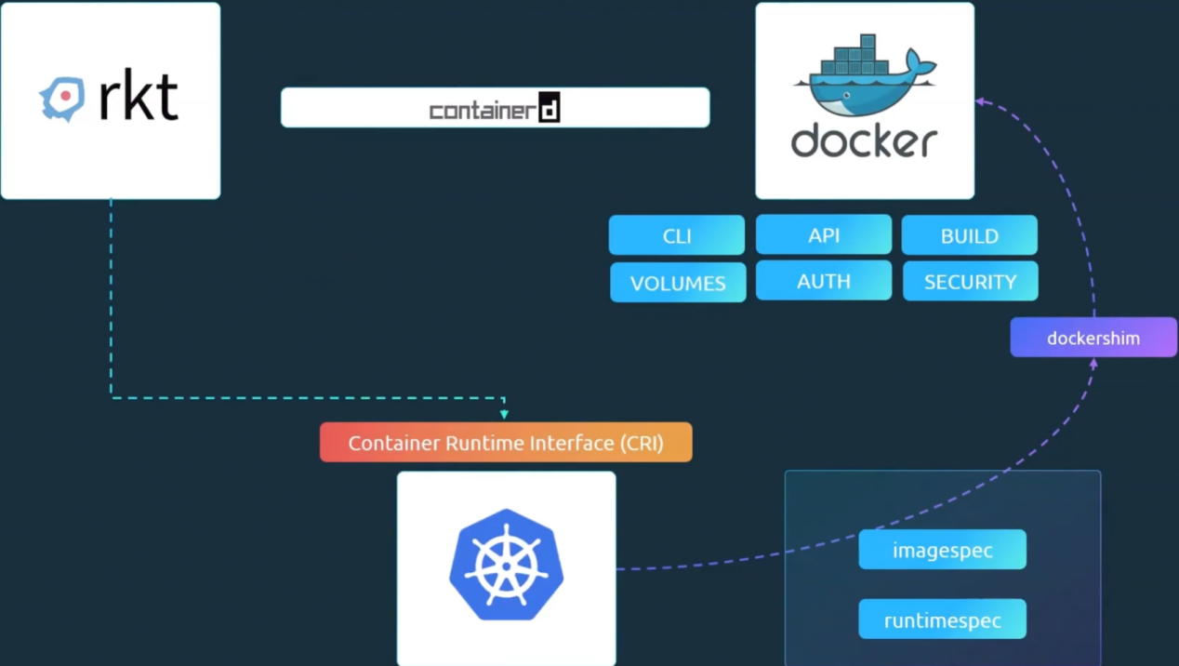
  - Docker has multiple things that work like docker cli, api, volumes etc etc.
  - containerd is CRI compatible, can be used as a container runtime separately with Kubernetes.

- NOTE about Docker architecture layers ------------------------------------------------------
- 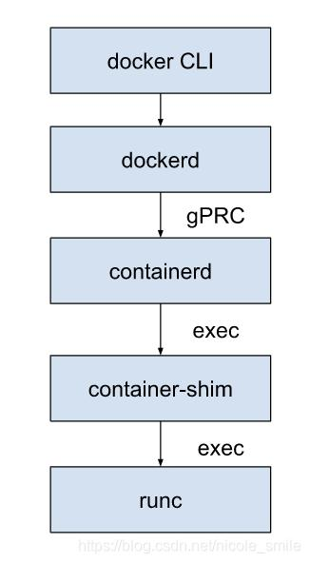
- When you run docker run nginx, internally the below happens
  - Docker CLI sends request to dockerd.
  - dockerd (docker daemon) does image pull, container setup, volume setup, container config.
dockerd is the brain of docker.
Then, it calls containerd.
  - containerd calls runc.
It actually creates a contaienr (namespace, cgroups)
- docker = dockerd (manager) + containerd (executor) + runc (low-level runner)
- The parts of docker:
  - Docker CLI
    - the docker command you type.
    - It talks to the docker daemon (dockerd) via REST API.
  - Docker Daemon (dockerd)
    - Its brain of Docker.
    - It handles containers, images, networks, volumes.
    - Exposes API for CLI/Tools.
  - Docker API
    - REST API used by CLI, or external tools.
    - Ex: Docker Desktop, CI tools
  - Docker Build System
    - Builds images from Dockerfile.
    - Internally uses Buildkit (modern Docker).
  - Docker objects (managed by Docker)
    - Containers, volumes, networks, images.
- The parts outside of Docker.
  - Container Runtime (high level)
    - containerd, it manages pulling images, container lifecycle.
    - Originally part of docker, now a separate CNCF project.
  - Low Level Runtime
    - runc
    - Actually creates containers using namespace, cgroups.
  - --------------------------------------------------------------------------------------------------------
- How images are built?
  - Docker is something that calls containerd which further calls runc to create an image.
  - Any vendor can use containerd and create image.
  - It doesn’t mean that docker is just a tool like others. It’s a complete platform which contains
    - CLI (docker)
    - Daemon (dockerd)
    - Image build system (buildkit)
    - Networking, Volumes, Image management
  - It internally uses containerd and runc.
  - containerd: pull, start, stop the container
runc: actually runs the container (namespaces, cgroups)
  - Before
kubernetes -- dockershim -- Docker -- containerd -- runc
  - Now
kubernetes -- containerd -- runc
  - Kubernetes removed docker completely from its pipeline.
  - You just build the image and push in the registry, rest of the things will be done by Kubernetes.
Because anyways it uses containerd which can pull and delegate the call to runc to run the container.
Docker now adapted to CRI standard, so it builds CRI standard images that can be directly used by Kubernetes.
  - Docker is having Docker Networks, Volumes, Lifecycle, How will they all be managed without Docker in Kubernetes?
    - For networking, Kubernetes has CNI which is very powerful.
    - For Storage, PersistentVolumes, PersistentVolumeClaims, StorageClasses are there.
    - For lifecycle, pods and replica management is there.
- Kubernetes has crictl to talk to containerd in runtime for debugging purpose.
  - Docker doesn’t use crictl to talk to containerd (don’t get confused on this)
  - Both dockerd and crictl talks to containerd but in different ways.
    - dockerd talks to containerd via its own API (gRPC)
    - crictl talks to containerd via CRI plugin (CRI API)
  - 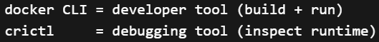
  - 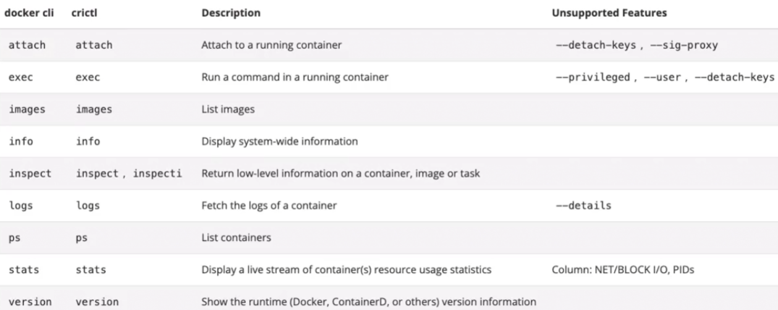
  - crictl can connect to any CRI configured runtime, not only containerd.
- F

- Minikube
  - It provides a single node environment where all the processes of both control plane and data plane are present in a single node.
  - 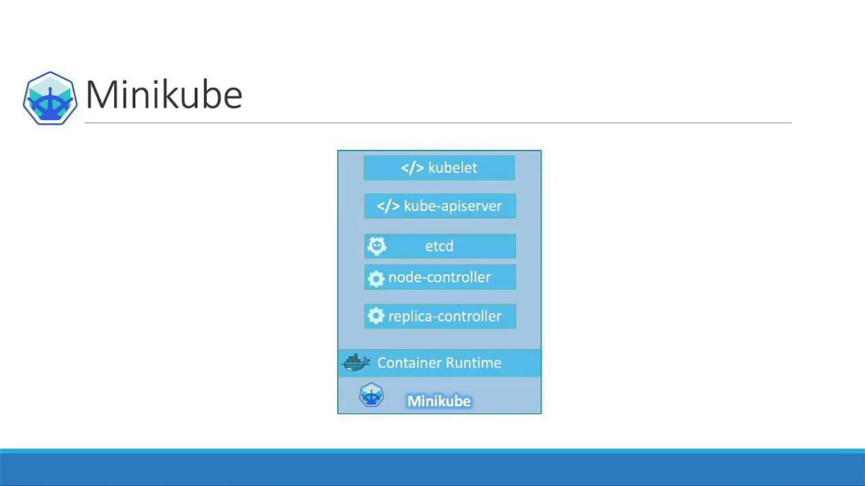
  - it provides an iso image directly that can be run using any virtual box like VM ware, virtualbox ..etc.
  - minikube start --driver=virtualbox (use --driver to run minikube inside virtual machine)
- Pods
  - The Nodes doesn’t run the application directly. Rather the container is wrapped with an object called as pod.
  - It is the smallest object that can be created in Kubernetes.
  - Do not add multiple containers inside a single pod if you want to scale, rather create different pods for that.
And for CPU or other usage, then run the pods in multiple nodes.
  - Its not a restriction that we can create only one container inside a pod, we can create many.
But, those containers shouldn’t be of same kind.
There are use-cases that create helper containers along with the application container inside the same pods which lives and dies along with the main application container.
  - The application and helper containers can communicate with eachother.
- Why Helper containers?
  - Lets see only docker containers for now.
  - You have some application containers. But as your app grows, you need to process some data.
So, you created some other containers to process the respective containers.
  - Now, you need to keep shared volumes for each application and helper container pairs.
  - 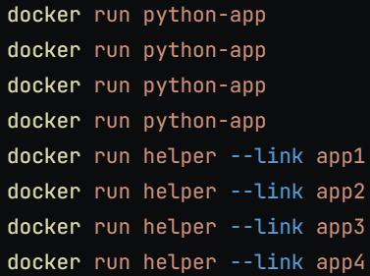 (-link is the legacy method to link one container to another in docker)
Now, you need to keep track of the containers like
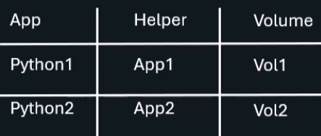
  - With Pods, Kubernetes does all these by default.
All the containers inside a Pod can access each other, can access the same volume, and created and destroyed together.
  - Multiple containers are very rare usecase.
- To create a Pod
  - 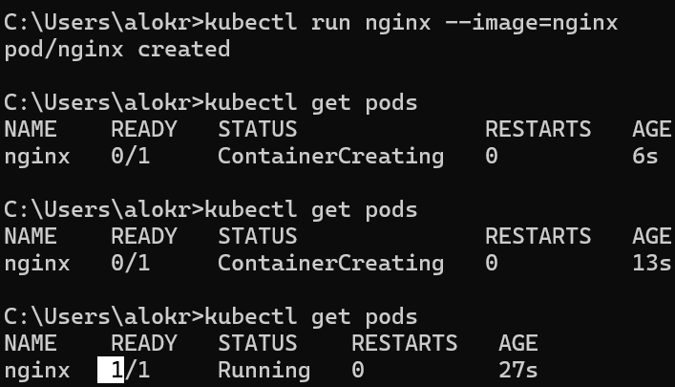
    - kubectl run <name> --image=<image name>
it’ll pull the image from docker registry and create a pod and run the container inside that.
  - 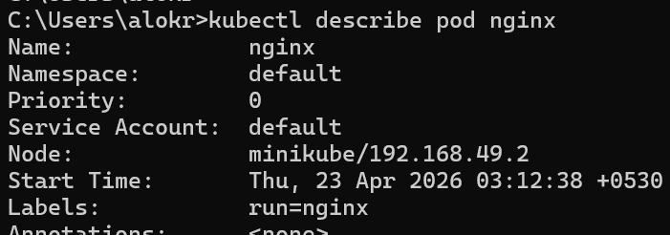
kubectl describe pod <name>
it displays a lot of details about the pod.
Also, one more command is there kubectl get pods -o wide

- F
- F
- F
- F
- F
- F
- F
- F
- F
- F
- F
- F
- F
- F
- F
- F
- F
- F
- F
- F
- F
- F
- F
- F

Commands
- kubectl get nodes -o wide
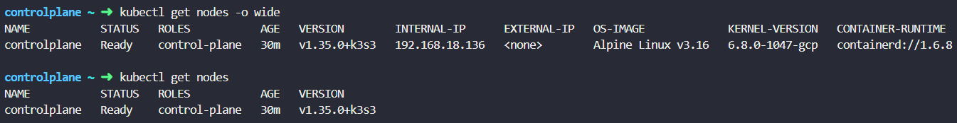
it gives extra details about the nodes.
  - You can see the OS-IMAGE using
cat /etc/os-release
but, for this you need to have access to that node or you need to do ssh to that node and do this.
  - On the other hand, kubectl command has all the nodes registered and without ssh or something else it can provide you the details.

- F
- F
- F

